**2D FDTD with PML (working Title)**

*Authors: Adedayo Lawal and Blake Levy*

**Abstract – A two dimensional finite difference time domain (FDTD) simulation is presented. The computational domain is surrounded by a perfectly matched layer (PML) which is terminated by a perfect electric conductor (PEC).**

1. **INTRODUCTION**
2. **FORMULATION**
   1. **Yee Cell**

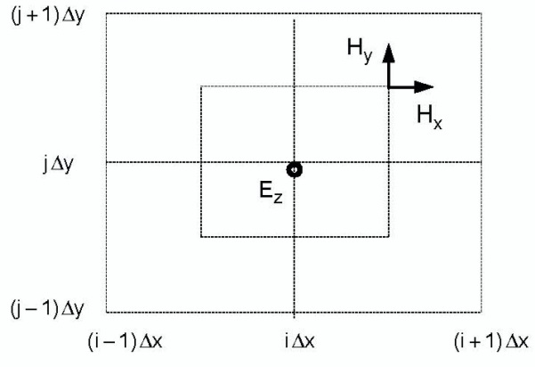In order to simulate the electric and magnetic fields in a 2-Dimensional geometry, a conventional Yee Cell method was used. Figure 1 shows the half-step offset of the magnetic field grid related to the electric field grid.

Figure 1 Staggered Grid1

The project defined a current source that was oriented in the plane perpendicular to the field grid. As a result of this current source, the only nonzero electric field component was in the direction of the current source, $E_{x}$, whereas the nonzero magnetic field components corresponded to $H_{y}$ and $H_{z}$ which indicated transverse magnetic (TM) field behavior. Equations (2.1a)—(2.1c) are derived from Faraday and Ampere’s law in a Cartesian two-dimensional geometry based upon our source-free, non-zero electric and magnetic field components.

* 1. **Dispersion Relation**
  2. **Permitivity Discontinuity**
  3. **Perfectly Matched Layer (PML)**

1. **RESULTS**
2. **CONCLUSION**
3. **REFERENCES**